SMS Manager in Android with NEXMO API

Create the following interface

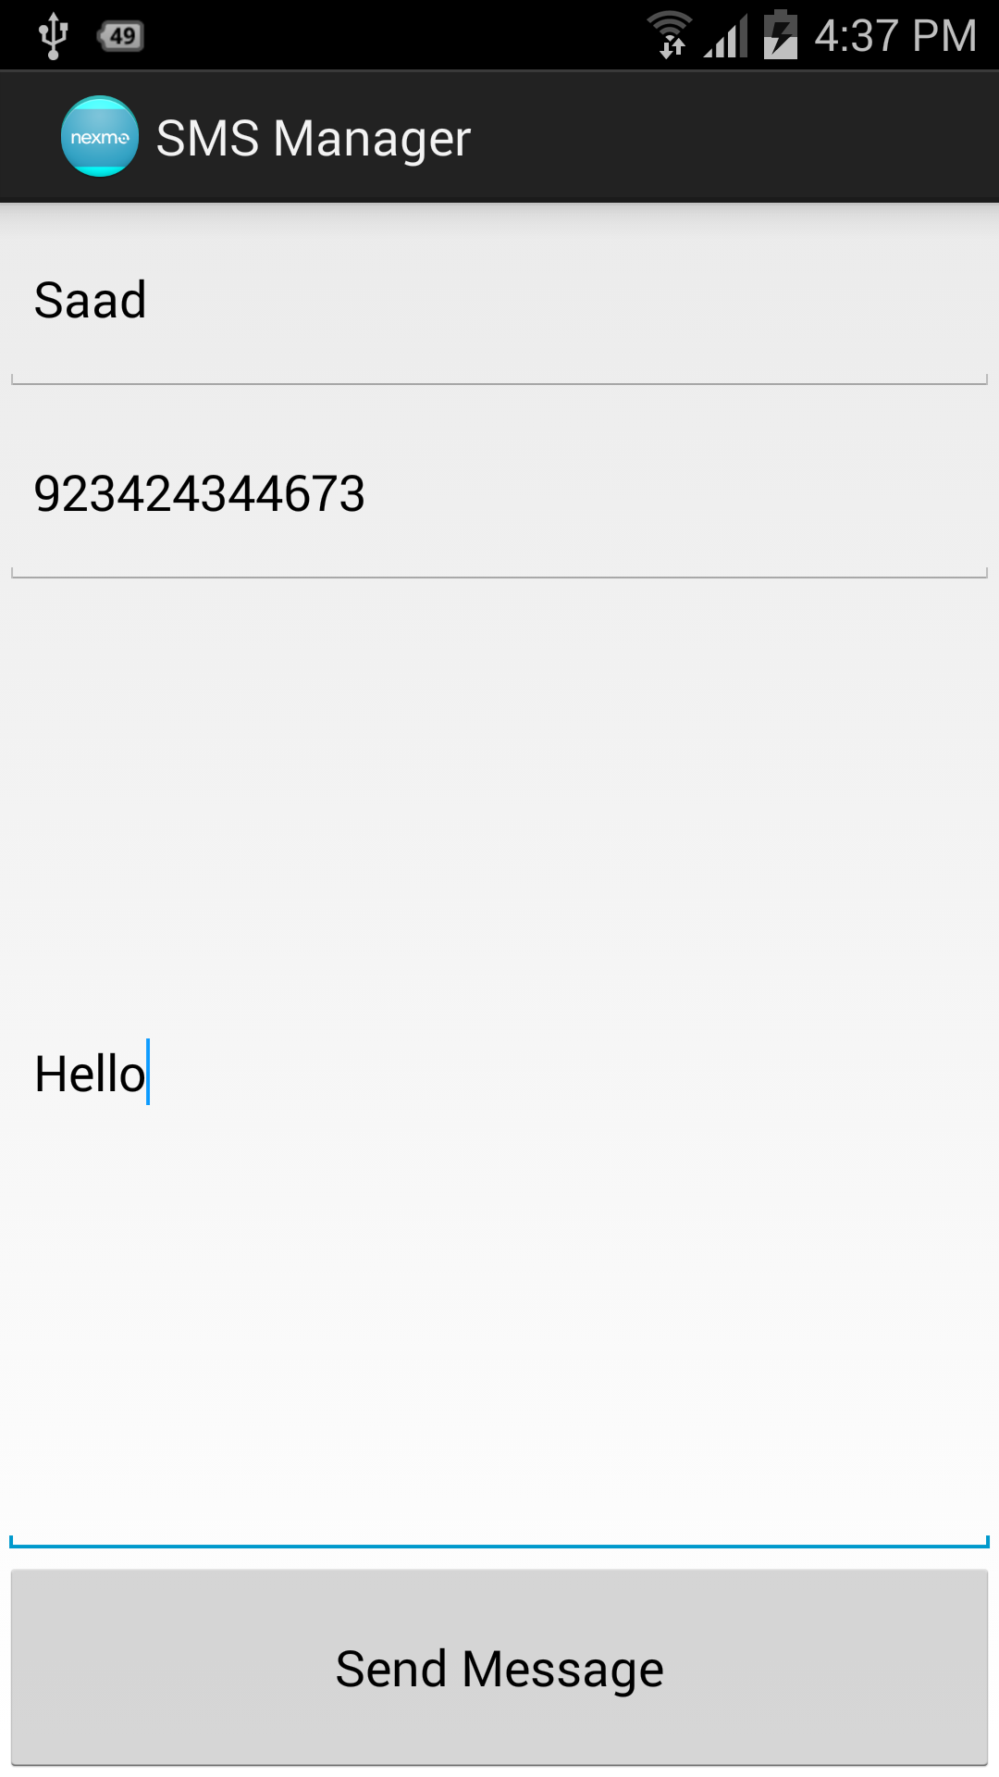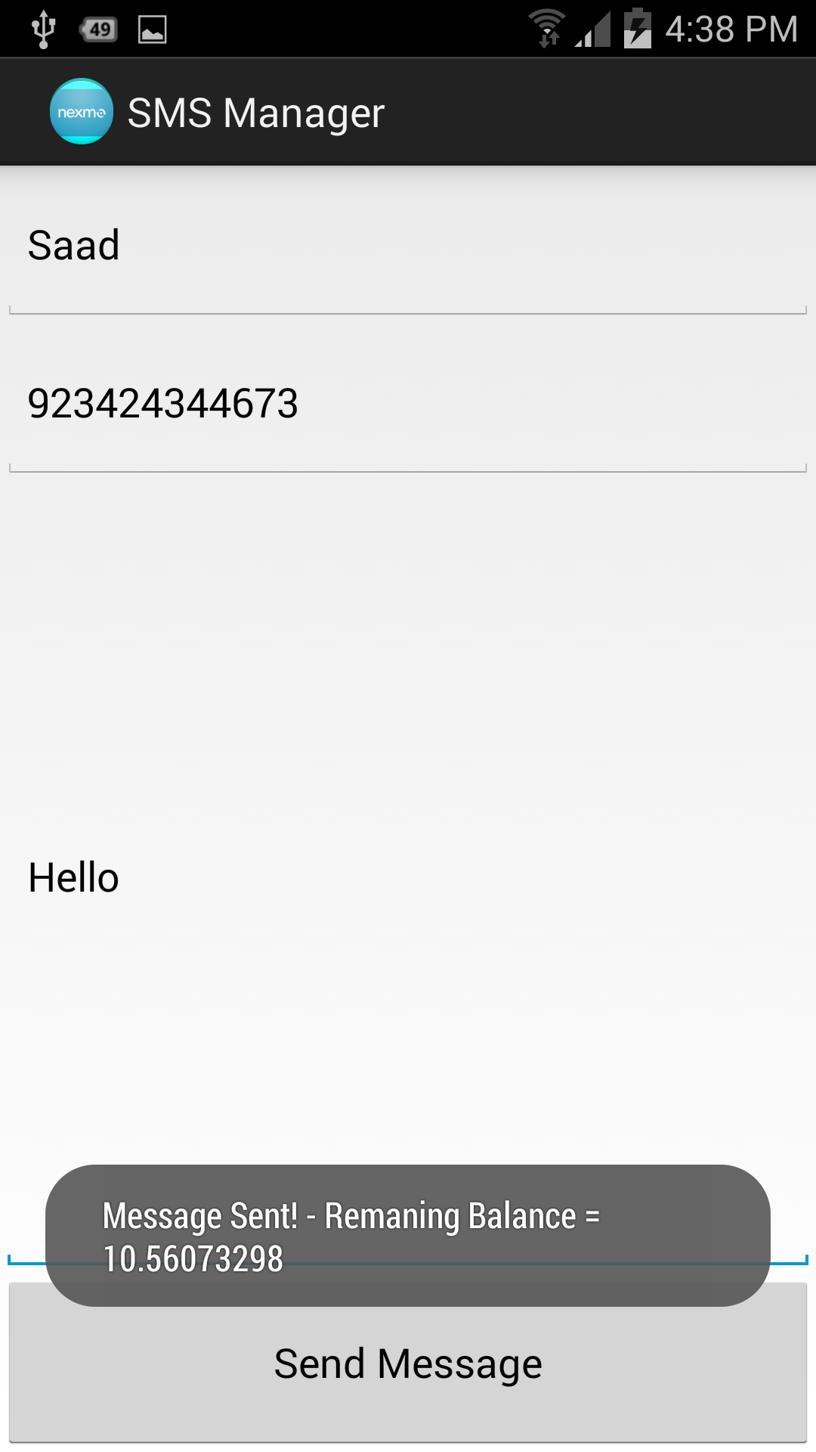

When user presses Send Message – A message should be sent via AsycnTask and (ensure that you grant internet permissions to your application in the manifest) and parse the reply and show the remaining balance.

Note- If user is not connected to internet – then the following toast should appear and your asynctask should be cancelled. (i.e execute should not perform!).

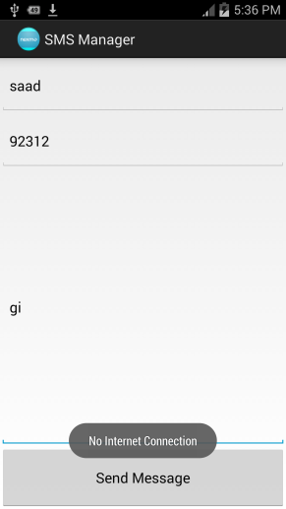

Reference:

<http://www.androidhive.info/2012/01/android-json-parsing-tutorial/>

<http://www.vogella.com/tutorials/AndroidNetworking/article.html>

http://developer.android.com/training/monitoring-device-state/connectivity-monitoring.html